* [Types of Loops and Their Uses](https://www.microverse.org/blog/how-to-loop-through-the-array-of-json-objects-in-javascript" \l "toc-types-of-loops-and-their-uses)
* [1. The “While” Loop](https://www.microverse.org/blog/how-to-loop-through-the-array-of-json-objects-in-javascript#toc-1-the-while-loop)
* [2. Do While Loop](https://www.microverse.org/blog/how-to-loop-through-the-array-of-json-objects-in-javascript#toc-2-do-while-loop)
* [3. The ForEach() Loop](https://www.microverse.org/blog/how-to-loop-through-the-array-of-json-objects-in-javascript#toc-3-the-foreach-loop)
* [Looping through JSON in more detail with examples](https://www.microverse.org/blog/how-to-loop-through-the-array-of-json-objects-in-javascript#toc-looping-through-json-in-more-detail-with-examples)
* [Conclusion](https://www.microverse.org/blog/how-to-loop-through-the-array-of-json-objects-in-javascript#toc-conclusion)
* **The ‘For’ Loop**
* The For Loop comes first because of its simplicity and ease of use. It is a very user-friendly kind of loop that runs with a method of using a counter.
* The value is first set with an appropriate condition, which is also called ‘initializing a loop’. Next, the terminal or final value is specified. The For Loop makes things really easy when you need to run a set of codes multiple times.
* The For Loop is further divided into:

#### **2. Making a loop through DOM elements**

The For loop can also be used to alter colors. Consider a situation where you want to choose a particular color for all the anchors of your page. In order to do so, use the following piece of code.

var elements = document.querySelectorAll("a");  
for (var i=0; i<elements.length; i++) {  
   elements[i].style.color = "red";  
} **‍**

When you look at the above code, things might not seem very clear.

I first used `**document.querySelectorAll("a")`**to get all of my anchors in the array format. Once that was done, the next step looped all the array and changed its color.

Here, we used the color red, but you may choose any color in the code and the anchors of your page will appear that particular color.

In order to better understand this visually, here’s the output of when I ran this code on the W3Schools site:

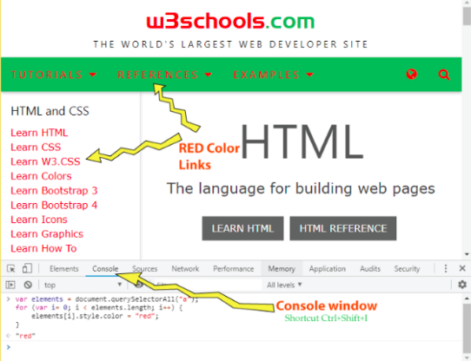

You can see that the color of the anchors has been changed to red.

### The ‘For In’ Loop

Another way of looping is the For In Loop. Unlike the For Loop, this loop won’t be using a counter. So this makes the whole process even more simple and hassle-free. In fact, the For In Loop is essentially a simplified version of the For Loop.